
#4
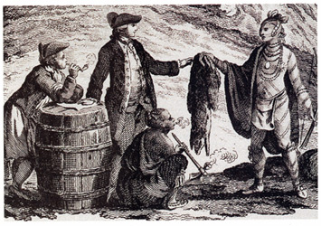
NORTHWEST COMPANY
JOHN SPEARN

From the album ‘Canada Songs’

Vocabulary

- Scot -
- bush -
- no-man’s land -
- Northwest Company -
- Metis –
- bonnie -

Do You Know It?

Can you map the following places?
- Montreal
- Scotland
- Glasgow

Did You Catch It?

- Is this land area really “no-man’s-land”? Whose land is it?

- How many days is three long years and 17 months?

- Why can’t the narrator leave in summer or fall?

- In the chorus, there is a background voice. Is there any significance in the two voices?

- What did the first nations people teach the white people?

32

Do You Get It?

- How would a First Nation’s person, at the time, view the narrator’s perception of the land?
- Line 13 refers to “a native lass” who is to be traded. What is this line suggesting?
- Consider the tone, mood and imagery of this song and “Les Voyageurs” by Mike Ford. Compare the two songs and create a Venn diagram demonstrating the similarities and differences.
- What does the narrator mean when he says, “so it’s here I cut my stone” (line 25)? Interpret this in a short paragraph.
- The song is written like a letter. Who do you think he is writing to? Explain.
- If someone dislikes their job why do they continue to work at it?

Activities and Extensions!

- Create a diorama showing a scene from the song.
- Create a recruitment poster convincing people to work for the Northwest Company.
- Research living conditions for employees of the Northwest Company at this time.
- Imagine you are a Voyageur, what would you need to take with you to survive?
- How were other Nor’Westers (like Alexander Mackenzie, Simon Fraser, and David Thompson) like and different from the narrator of this song?

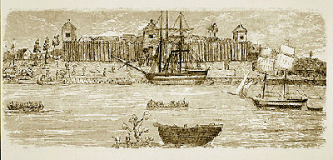

Fort Kaministiquia
(Fort William)

Kaministiquia (formerly Fort William) was the hub of the North West Company's fur trade empire.

(courtesy Library and Archives Canada).



Teacher’s Guide

BACKGROUND INFORMATION

The North West Company (NWC) was a fur-trading enterprise based in Montreal and active in the Canadian West from the 1770s until 1821. The company was run mainly by Scots immigrants who came to Montreal after 1760. They relied for their workforce on French-Canadian voyageurs who had been trading in the fur country for years.

Nor'Westers, as the company men were called, were among the most daring adventurers and skilled traders in the Northwest. The era of the North West Company was one of the most colourful in Canadian history.
www.thecanadianencyclopedia.com



ARTIST INFO

John Spearn You’ll instantly catch these deep influences threaded throughout John’s fine vocals, lyrics, and rootsy, guitar-mastered songwriting works. His grant-supported Canada Songs and Northern Sightlines CDs have taken him from coast to coast as a major festival performer, workshop host, historical curriculum writer, and multiple award nominee. This is pure Canadiana: forgotten but deserving heroes, the humility in our international image, and stories that need to be told. www.canadasongs.com

ANSWER KEY

- The Northwest Company owns this land.
- The First Nations’ people know the land – it allows them to live and is respected.
- This line is suggesting that a “marriage” is in the works.
- The differences are generally found in the tone of each piece. “Les Voyageurs” uses humour and onomatopoeia to create a sense of adventure. The mood is generally upbeat. “Northwest Company” has a much more bleak and forbidding feel to it. There is a sense of hopelessness and despair. Both songs talk of the challenges and hardships experiences in this life.
- Approximately 1,610 days
- He figures he will die and a gravestone will be “cut”.
- These are the high seasons for furs.
- Perhaps suggest that the narrator’s loneliness has rendered him out of touch with reality.
- Hunting, trapping, survival skills in a harsh environment.

ADDITIONAL RESOURCES

- http://www.quebecoislibre.org/05/050515-9.htm

- http://www.canadiana.org/hbc/stories/colony4_e.html

